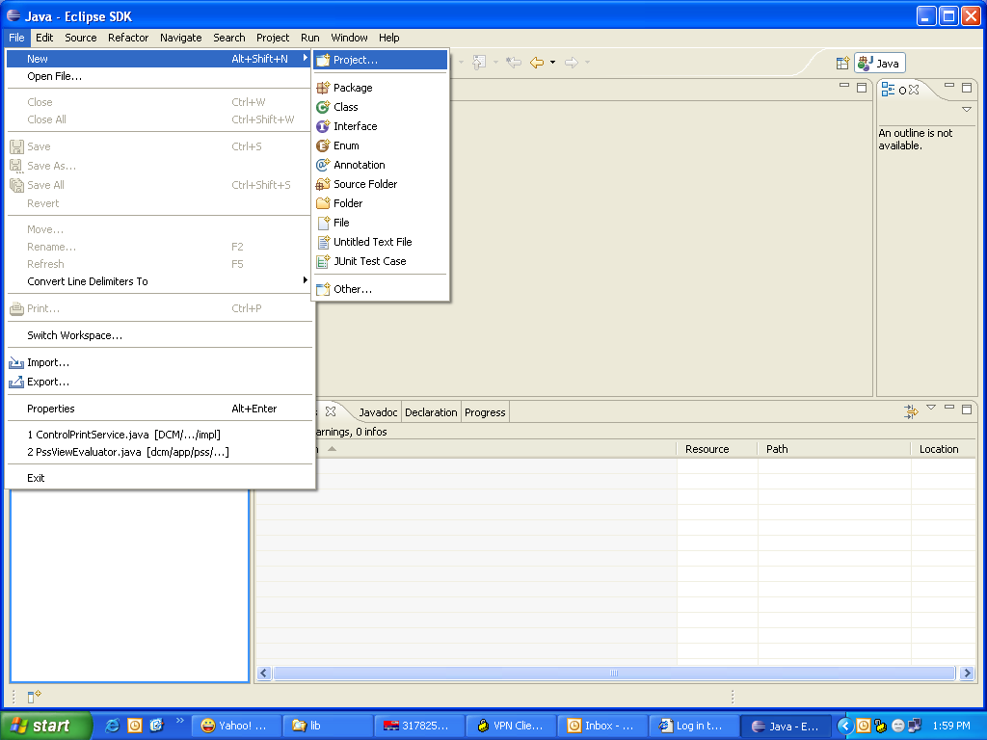

Click File > New > Project
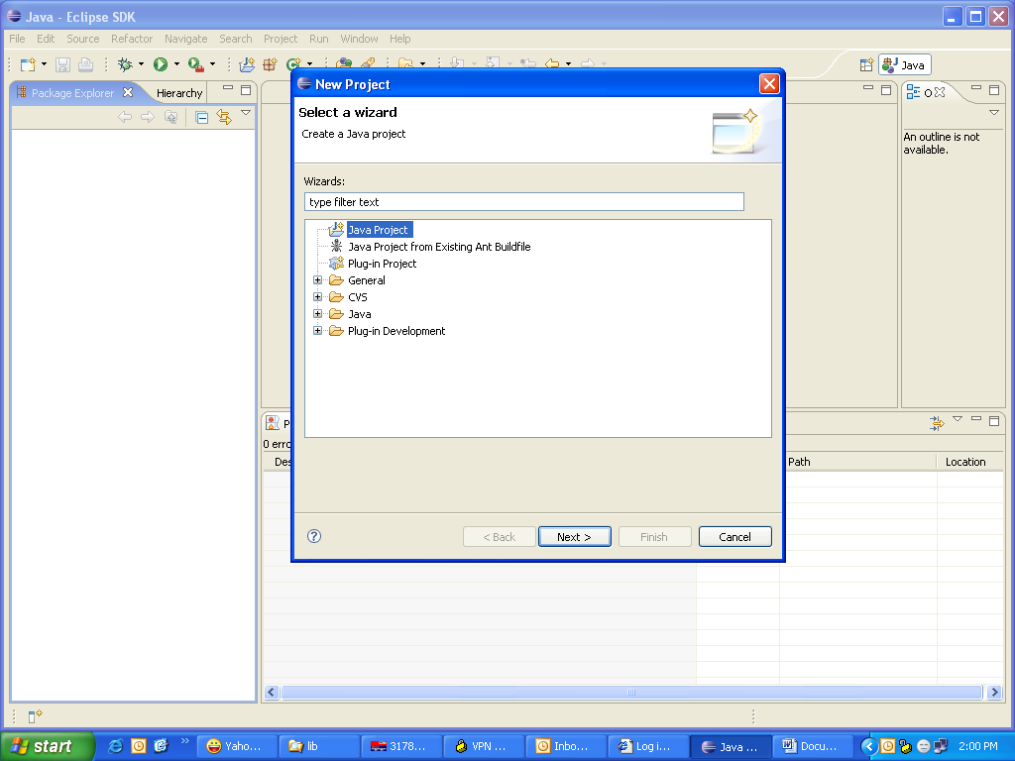

Select java Project and click Next
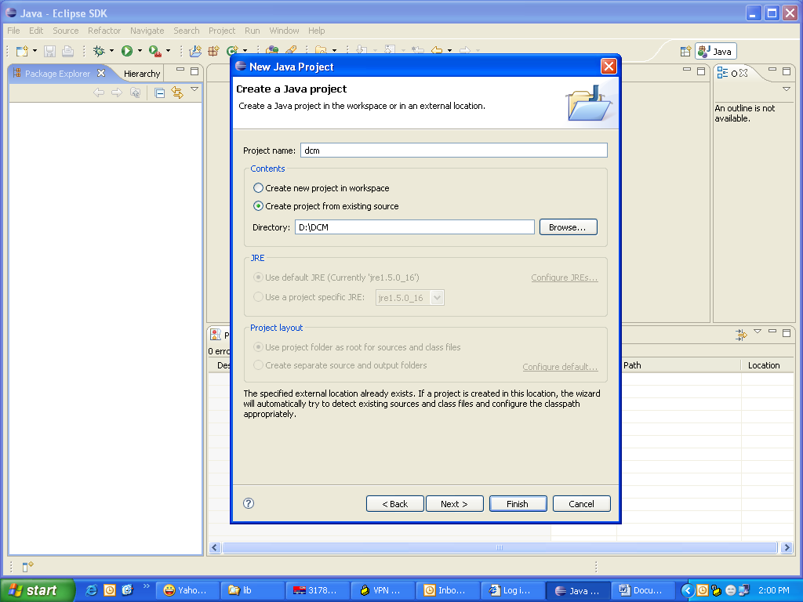

Specify a name for the project, select the radio button “Create project from existing source and select the folder containing the source code for the project. Then click Next
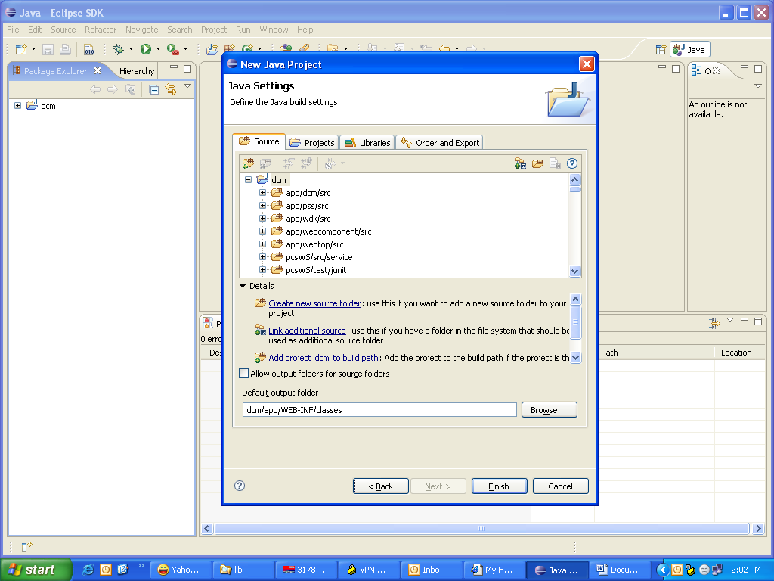

Check the default output folder and if it s wrong, select the correct path. Click on libraries tab
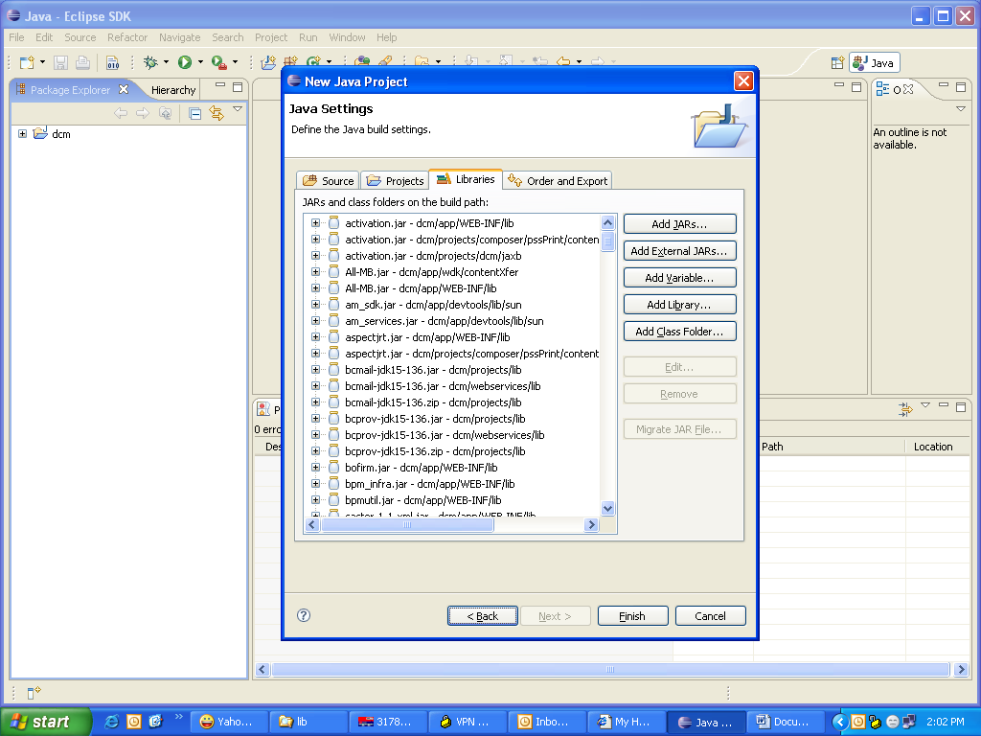

Remove the JRE library added and Click on Add library to add the JRE library available in your machine.

Then click on Add Jars and add all jar and zip files in the source folders.
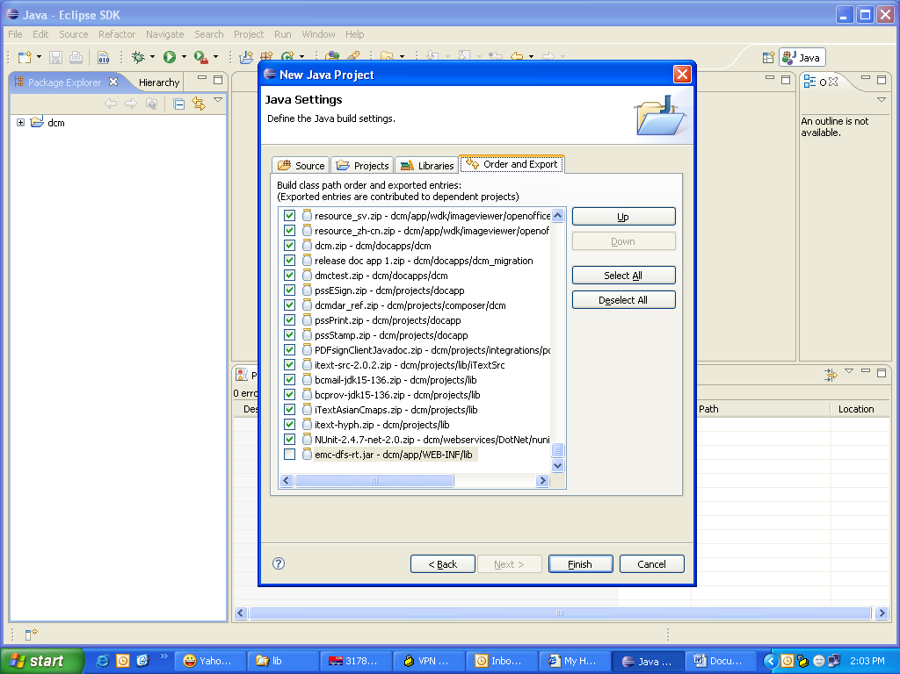

Click on Order and Export tab and click “Select All” button. Then click on JRE library and click “Up” button and move this next to all the source folders.

Click Finish and build the project.

Configuring Tomcat for Debug Mode

1) In the eclipse window, click on the debug icon, select "Remote Java Application" from the list of configurations. Right click on the "Remote Java Application" and create a new configuration for your application.
On the right hand side, there will be three tabs, namely "Connect”,"Source" and "Common". Click on the "Connect" tab and set the connection properties, host as "localhost" and port as "8000".
2) In the environment variables, add an entry jpda_address=8000; this is the default connection port used by eclipse when you try to connect to a remote VM for debug.
3)Open catalina.bat (inside the bin folder of tomcat) and search for "set JPDA_TRANSPORT". Set the value to dt_socket.
4)Open startup.bat(inside the bin folder of tomcat) and search for call "%EXECUTABLE%" start %CMD_LINE_ARGS%. It’s at the end of the file. Replace this with call "%EXECUTABLE%" jpda start %CMD_LINE_ARGS% (mind the spaces, better copy and paste).
5)Save the changes and start the tomcat server using its startup.bat file. The first line appearing on the server window should be "Listening for transport dt_socket at address: 8000. This indicates that all is well…

